Nicholas Pun 27872167

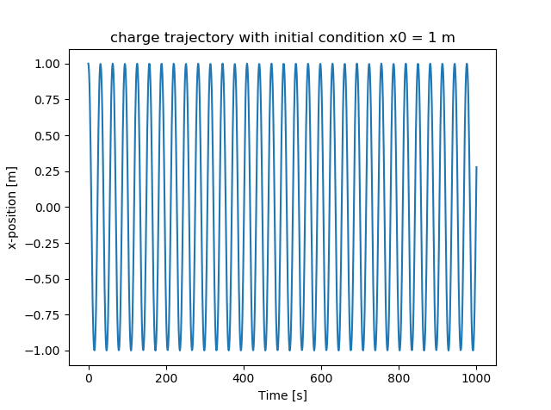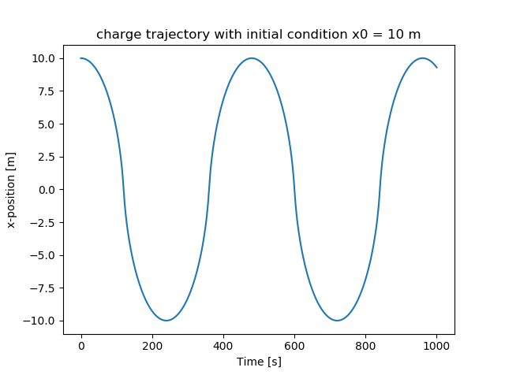

The difference between these two is that the closer starting position of 1 m produces a trajectory of much higher frequency than the trajectory which started at 10 m. Both trajectories are periodic due do the fact that when the charge crosses the ring, the sign of the force applied on the charge by the ring flips. They are also both of constant amplitude due to the absence of any damping coefficient. The 1m wave also has a smaller amplitude at 1m versus the 10m wave at 10m.

# -*- coding: utf-8 -*-

"""

Created on Thu Sep 26 15:45:08 2019

@author: Nick

"""

import numpy as np

import matplotlib.pyplot as plt

# define constants

Q = 1e-6

m = 0.1

t0 = 0

R = 1

tf = 1000

x0a = 1

x0b = 10

eps = 8.854e-12

k = 1/(4*np.pi*eps)

dt = 1

x0 = x0b

# set up arrays for position and time

tarr = np.linspace(t0,tf,tf+1)

xarr = []

varr = []

# define a function that returns the force or acceleration

def acc(t):

return (-Q*Q*k*xarr[t]/(R**2+xarr[t]**2)**(3/2))/m

# set initial position and velocity

xarr = np.append(xarr,[x0],axis=0)

varr = np.append(varr,[0],axis=0)

# integrate equation of motion

vdt = 0

for i in range(1000):

vdt = varr[i] + acc(i)*dt/2

xarr = np.append(xarr,[xarr[i] + vdt*dt],axis=0)

varr = np.append(varr,[vdt + acc(i+1)*dt/2],axis=0)

# plot trajectories

plt.figure()

plt.title('charge trajectory with initial condition x0 = 10 m')

plt.xlabel('Time [s]')

plt.ylabel('x-position [m]')

plt.plot(tarr,xarr)

plt.figure()

plt.title('charge velocity with initial condition x0 = 10 m')

plt.xlabel('Time [s]')

plt.ylabel('x-velocity [m/s]')

plt.plot(tarr,varr)